National University of Computer and Emerging Sciences, Lahore Campus

 | Course Name: | Computer Org, & Assembly Lang | Course Code: | EE2003
 | Degree Program: |  | Semester: | Fall 2023
 | Exam Duration: | 140 Minutes +10 Min(Submission) | Total Marks: | 100
 | Paper Date: | 9th January,2024 | Weight | 40
 | Section: | All BCS & BDS Sections | Page(s):
 | Exam Type: | Final
Student : Name:_____________________________ Roll No.________________ Section:_______
Instruction/Notes: | - Attempt all questions. Programmable calculators are allowed.  - This is an Open book & Open notes Exam. Only Hard form Notes and Book is allowed.  - Use of Internet is NOT ALLOWED.  - All Questions are meant to be attempted by all sections of BS CS and DS unless mentioned on the question. Make reasonable assumptions in case of any confusion, questions during exam are not allowed.  - Submission Instructions:  - Make an unzipped folder and rename it with your Roll-No. Place your .asm files of each question and also rename them as Roll-No Q# e.g. l21-1234q1.asm.  - Submit above folder to XEON/Fall 2023/Slot 1/BS (your degree program)/ Your Section/ Your Lab Section. E.g. For Section A of BSDS its XEON/Fall 2023/Slot 1/BS DS/Section A/ A1 Submission
Task 1: [30]
Write a program that will display a rectangle of length 26 representing Columns and width of 10 representing Rows. The boundary of the rectangle displays the Capital Alphabetic letters and small alphabetic letters to the extent of their respective lengths. The display must be in the following manner as displayed.
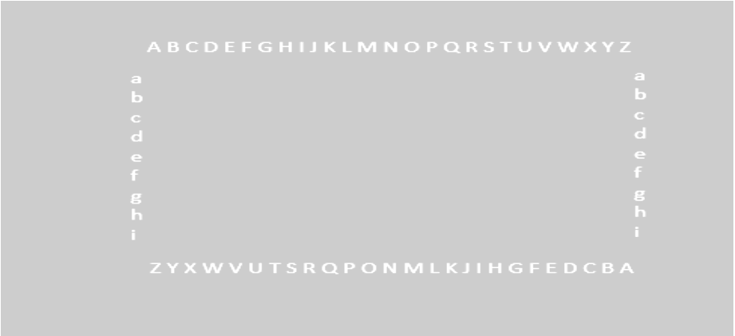

Note: This Display is originally in black background and White Foreground. You all are advise to follow the original. These changes has been made for printing purposes.

Task 2: [30]
After Task 1, write a program that will rotate the contents of the boundary in clockwise manner using subroutines. After one subroutine, one letter must be shifted to the next location of the rectangle in cyclic motion. Write a main program that will run 10 cycles of rotation. Each Rotation must be displayed and then next rotation must be done after that. A 2 Cycle rotation has been shown below.
After Cycle 1: After Cycle 2:
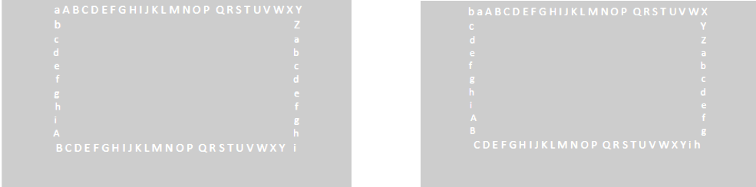
Task 3: ( Only BS CS Sections A to J will attempt this task ) [20]
Write a program that will perform Task 2 using timer interrupt. You have to write Timer Interrupt Service Routine in order to do the rotation after every 2s.
Task 4: ( Only BS CS Sections A to J will attempt this task ) [20]
Update the program written in task 3 such that it keeps rotating the rectangle unless the user presses key ‘P’ (P = Pause Functionality). It will resume the rotation if user presses key ‘R’ (R = Resume Functionality). You have to use Keyboard interrupt to implement this functionality. Using Software Interrupt is not allowed for this functionality.
Task 3: ( Only BS DS Sections A & B will attempt this task) [20]
Write a program that will enlarge and reduce the size of the Rectangle upon receiving the new length and width from the user using software interrupts . The contents of the boundary of the rectangle also changes with the length and width of the rectangle. In case of enlargement , the alphabets will be repeated. For example if the new length is 30 then after Z A B C D will be displayed again. For reduction, the contents will also reduce. For example if the new width is 5 then only a b c d e will be displayed in the vertical boundary.
Task 4: ( Only BS DS Sections A & B will attempt this task)
Write a program to make Task 2 into infinite loop unless ‘P’ key is pressed on keyboard. If the key ‘R’ is pressed the cycle must again enter the infinite loop. Key ‘P’ and ‘R’ are used to pause/resume the Rotation process respectively. You have to use Keyboard interrupt to implement this functionality. Using Software Interrupt is not allowed for this functionality.

